**Supervised Machine Learning**

In this type of learning, algorithm learns x to y or input to output mappings.

Learning algorithm is fed with “correct examples” and by seeing correct pairs of x and y, it learns to take just input x alone and predict the output.

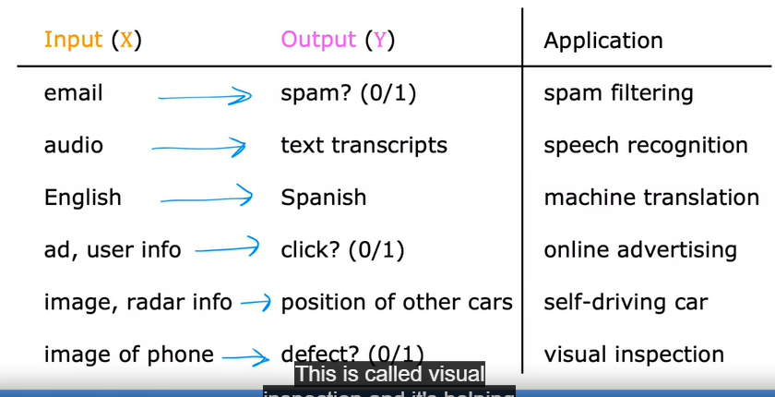

Calculated/Known data(X-Y) is fed into the algorithm, algorithm then decides to predict Y for an unknown data X.

Example:

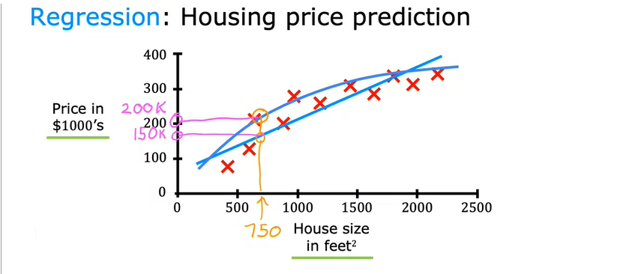

Algorithm should choose the best line/curve which fits the given data.

In the above example of House price prediction, the algorithm predicts a **number** out of many(**infinitely**) possible numbers.This type of Supervised learning is called **regression**.

There is one more type of supervised learning,